INVENTION DISCLOSURE FORM

Duty to report: Pursuant to the HKU IPR Policy, patentable inventions made by staff in the course of employment or students in the course of study must be disclosed to the Technology Transfer Office (TTO) of the University.

Invention Disclosure Form (IDF): This IDF serves as a confidential legal document that records the conception of the invention and the circumstances under which it is created, and provides a basis for full discussions and analysis of the invention’s patentability, commercial potential, ownership and contractual obligations. It should be completed electronically.

Patent Evaluation Process: The fully completed IDF of the latest version must be submitted to TTO in order to initiate the patent evaluation and commercialization processes. The initial evaluation generally takes 4 to 6 weeks and consists of the following stages:

- Inventor(s) submit a fully completed IDF, with supporting documentation such as manuscript, data and drawings, if any.
- If the submitted IDF contains sufficient and correct information, TTO confirms receipt of, assigns a reference number for, and arranges evaluation of, the IDF. If the information is insufficient and incorrect, the IDF will be returned to the PI for further revision.
- If the invention disclosed in the IDF is approved by TTO Patent Evaluation Committee (PEC) for patent protection, TTO notifies the inventor(s) and instructs external patent attorney for drafting and filing of patent application(s). If, on the other hand, the PEC decides not to file patent(s) for the invention, or that more information or data are needed for the PEC to reach a final decision, whichever is applicable, TTO will notify the inventor(s) accordingly. In the event that the PEC decides not to file patent(s) for the disclosed invention, the inventor(s) may request the University, in writing via email or a posted mail, to waive its interest and assign the IP right back to the inventor(s) for disposition at the inventor(s)’s own costs.

Submission: Please submit a word editable copy of the fully completed and duly signed IDF to ipmteam@tto.hku.hk.

Guidance and Inquiries: A detachable guide is attached at the end of this form as Appendix A: Guidelines for Completing the IDF. It provides detailed explanations and instructions on how to complete each part of the disclosure form. For additional advice or information, please contact TTO Intellectual Property Management Team at 3917 3107 or ipmteam@tto.hku.hk.

1. INVENTORS
a. HKU inventors
*Please enter the complete legal name as shown on HKID card, passport, or other identity document.
 | Inventor 1 | Inventor 2 | Inventor 3 | Inventor 4 | Inventor 5

Surname *

(in English)

Given Name *

(in English)

Surname *

(in Chinese)

Given Name *

(in Chinese)

Citizenship
Department | Choose or Type | Choose or Type | Choose or Type | Choose or Type | Choose or Type
Position/Title | Choose or Type | Choose or Type | Choose or Type | Choose or Type | Choose or Type

Staff or Student No.

Residential address

HKU address

Email address, Mobile number and WeChat ID

Intellectual Contribution (%)
Contact Person | ☐ | ☐ | ☐ | ☐ | ☐
 | If not from the above, state the contact person’s name, position, phone number, email and address for service:

b. Non-HKU inventors
*Please enter the complete legal name as shown on HKID card, passport, or other identity document.
 | Inventor 1 | Inventor 2 | Inventor 3 | Inventor 4 | Inventor 5

Surname *

(in English)

Given Name *

(in English)

Surname *

(in Chinese)

Given Name *

(in Chinese)

Citizenship

Position/Title

Name of Organization (Official Legal Name)

Residential address

Email address, Mobile number and WeChat ID

Intellectual Contribution (%)

Has HKU signed any agreement with the counterparty (the organization which the Non-HKU inventor works for) as regards the rights and obligations of the parties and the ownership of the IPs resulting from the collaboration?
☐ No agreement signed. | ☐ Negotiation in progress. | ☐ Agreement concluded.

Please fill out the requested information, and email TTO a copy of the relevant agreement(s), if any, when submitting the IDF.
Counterparty Full Name:
Name of the Agreement, if any
Date of Signature, if any:
Counterparty Contact Details | Email:  Tel.:  Contact Person:

- TITLE OF INVENTION
Note: The title should describe what the invention does, but not how it is made or how it works.
Systems and Methods for Enhancing Quality of 3D Model-Generated Window View Images

- BRIEF DESCRIPTION/ ABSTRACT OF THE INVENTION:
a. Provide a short general layperson’s overview of the invention and how it works.
Importance of Window Views
High-quality window views, e.g., sea, sky, greenery, and open views, are valued by urban dwellers. The benefits of window views include stress relief, physical restoration, and life satisfaction. As urban dwellers spend approximately 82% of time indoors, window views impact housing price and urban health and wellbeing, especially in high-density cities. For example, high-quality window views provide an important premium for the property price. In contrast, low-quality window views, e.g., the enclosed and close-range building wall views, can engender mood disorder, e.g., depression and stress, especially in densely developed urban contexts.

Collected window view images are important for housing marketing, built environment assessment for urban planning and design, and urban health. For example, window views can be showcased on property and developer websites to support sales and rentals. Additionally, window view indexes derived from these images can be added to property valuation models to improve price estimates. In urban planning, quantified window view images can inform planners of the buildings with low visual exposures to greenery, sky, and openness for prioritized urban renewal practices, e.g., construction of new green and open space in the surroundings. In architecture and building management, quantified window view images can guide the placement of key rooms, e.g., conference rooms, so they capture the best available views of the sea, sky, or greenery. In public health and equity, linking quantified views with health and well-being outcomes can inform policies for healthier high-density development, with special attention to low-income residents, older adults, and people with disabilities.

Low-quality issues of limited window view images
Currently, there are few window-view images available for housing, urban planning and design, or urban health applications. Collecting these images at scale is time-consuming and often impractical due to privacy concerns and the need to physically access every room. Images on property agency websites are typically captured manually by different people at different times, resulting in incomplete coverage and inconsistent resolution and shooting angles. Moreover, the images typically cover only a subset of units listed for sale or rent, while window views from other homes and buildings are missing altogether.

Recently, simulation of window views on 3D models in the computer system has enabled the availability of photorealistic window views for any building with the model. Window views can also be generated from 3D models for buildings to be built, enabling architects to optimize massing, unit layouts, and façade orientation and opening placement to deliver high-quality views for pre-sales. However, the quality of 3D model-generated window view images can be inconsistent due to distortions, blurring, and uneven texture quality across model patches. Thus, enhancing the resolution of 3D model-generated window-view images is significant to provide high-quality views for every flat, supporting applications in housing, urban planning and design, and urban health.

Limitation of current methods to improve the quality of 3D model-generated window view images
Current methods based on manual editing and Generative AI are challenging to improve the quality of window view images.

i) Difficulty of collection of high-resolution window view images as a reference to guide enhancement
First, collecting high-resolution window-view images in real-world settings is time-consuming and labor-intensive, and many cannot be collected due to privacy constraints. Second, window view images produced from more high-quality 3D models can still exhibit blurs and distortions due to existing models’ commonly limited-resolution representation of real urban landscapes. Last, discrepancies often arise between collected high-quality and original images, due to landscape changes across shooting dates and variations in camera settings and shooting locations.

ii) High-cost and uncontrollable window view image editing
First, image editing through software, e.g., Photoshop, is laborious and high time-cost to improve the low-quality issues, i.e., blurs and distortions. Without a high-quality reference, practitioners often lack clear guidance on the fine-grained adjustments. Second, the high-quality images from Generative AI own uncontrollable and randomly generated content.

In summary, due to high manual cost and uncontrollable enhancement of 3D model-generated window view images, current methods are incapable to improve the low-quality window view images at scale.

b. If the invention solves an existing problem or fulfil a long-felt need, what problem does it solve?

The purpose of the invention is to provide a system and method to improve low-quality 3D model-generated window view images by collecting high-quality window view images as reference, constructing window view pairs through segmentation, identifying the difference between low-resolution to high-resolution images/patches, and learning the difference through Generative AI. The low-quality issues to be solved include blurs, distortions, limited resolutions.

c. How does the invention solve the problem?

It aims to improve existing low-quality 3D model-generated window view images through four steps: i) collection of a high-quality reference window view image, ii) construction of window view image pairs, iii) representation of difference of image pairs, and iv) window view image quality enhancement using AI and difference-represented pairs.

Specifically, Step 1, corresponding high-quality reference window view images are collected for the AI model training in the Step 4. Example ways include real-world photography, or rendering from another high-quality 3D models, or generation using existing AI models from the computer system. Step 2, the original and the high-quality reference window view images are matched and segmented to construct pairs. The matched city objects with similar extents and landscape types in the image are paired, whereas others are excluded. Mismatches arise from: (i) photography setting differences (e.g., collection date, shooting angle, field of view), (ii) landscape changes across shooting dates, and (iii) random or unrealistic elements from AI generation. Step 3, the differences between the image/patch pairs are represented. Example methods include text descriptions and quantitative evaluation. Step 4, AI models, e.g., Generative Adversarial Network (GAN), and Diffusion, are trained or finetuned based on the difference-represented image pairs. The trained model is applied to enhance unseen low-quality window view images at scale.

d. Is it related to a new product, process, or composition of matter? Or is it a new use for or an improvement to an existing product, process or composition of matter? If so, what are the advantages of the invention over the existing ones, if any?

The invention is a new product and process to improve low-quality 3D model-generated window view images using AI.

e. Identify the elements that are considered novel and unobvious.

The novelty of this invention is as follows:
The disclosed methods and systems derive enhancement rules from constructed pairs of low-quality images and high-quality references—capturing texture, geometric, and resolution differences—and applies these latent rules to enhance unseen window-view images and patches with improved sharpness, fidelity, and detail.

Compared with the traditional enhancement of low-quality window view images and patches, the proposed system and method with learned enhancement rules between window view image pairs,
- avoid the direct manual enhancement of image quality, and thus reduce the labor cost,
- improve all three types of low-resolution issues, i.e., blurs, distortions, and limited resolutions, and
- reduce random generation of window view details.

- TECHNICAL DESCRIPTION OF THE INVENTION
Note: Please provide any relevant sketches, diagrams, drawings, photographs or other illustrative material. Description may reference a separate document such as a publication, meeting abstract, and manuscript in preparation, preprint or report. (Please insert information here or attach extra sheets.)
Attachment if any: ☐ Manuscript ☐ Presentation Abstract ☐ Drawings ☐ Data ☐ Others (please specify)
Problem Statement
Current two types of methods, i.e., manual editing and Generative AI, are challenging to improve three types of low-quality issues of window view images and patches, i.e., blurs, distortions, and limited resolution, without randomly generated details and window view structure.
This invention can effectively improve three types of low-quality issues of window view images and patches by learning enhancement rules between constructed window view image pairs. The enhancement system and methods comprise four modules: i) collection of a high-quality reference window view image, ii) construction of window view image pairs, iii) representation of difference of image pairs, and iv) window view image quality enhancement using AI and difference represented pairs (see Figure 1).
M1: Collection of a high-quality reference window view image. The reference high-quality image is generated through photography or Generative AI (see Figure 2). Photography is implemented either in the real world or on high-quality 3D models loaded into a computer system. To generate a high-quality window view image that preserves the landscape elements of the original, set the camera’s position (x, y, z) and orientation (heading, pitch, roll) to match the real or approximate parameters of the original image. The similarity between the resulting high-resolution image and the original is optimized by fine-tuning the camera parameters through manual adjustment, computer-aided scene-search algorithms, or a combination of both. For generative AI, existing foundation models are used to generate realistic high-quality window-view images, and similarity to the original is improved through manual or automated methods, such as iterative image regeneration.

M2: Construction of window view image pairs. The original and the high-quality window view images are first aligned and then segmented to construct pairs (see Figure 3). The matching methods include manual annotations, automatic image matching, or a hybrid of both. The segmentation methods include manual or automatic cropping or overlaying, or a combination of these methods.
The segment is at feature, patch, or instance levels. The feature refers to all segments with the same landscape type, e.g., building, greenery, or road, as a whole. The patch indicates separated segments with the same landscape type as multiple objects. The instance includes segments belonging to one entity. The construction process of segment pairs is presented using Equation 1.
Pairs (I_{o}, I_{h}) = {(p_{o}, p_{h}) | p_{o} ∈ P (I_{o}), p_{h} ∈ P (I_{h}), C (p_{o}) = C (p_{h}), S (p_{o}, p_{h}) ≥ τ}, | (1)
where I_{o} and I_{h} are original and high-resolution window view images, respectively. P is the set of features/patches/instances p clipped out from the image I. C is the function to classify the segments into semantic categories, e.g., building, greenery, and road at the feature/patch/instance level. S is the function to calculate the matching degree of the extent (e.g., boundary and pixel number). τ is the threshold with adjustable range and value according to partitioners’ needs. p_{o} and p_{h} are I_{o} and I_{h}, respectively, if both C (I_{o}) = C (I_{h}) and S (I_{o}, I_{h}) ≥ τ.

M3: Representation of difference of image pairs. The difference Δ_{l} between the image pair at the feature/patch/instance level is first represented using Equations 2 and 3.
Difference (I_{o}, I_{h}) = {Δ_{l} | Δ_{l} = D_{l} (p_{o}, p_{h}),  l ∈ L = {texture, distortion, resolution}}, | (2)
D (p_{o}, p_{h}) = {T (p_{o}, p_{h}), Q (p_{o}, p_{h})}, | (3)
where D is the function to quantify the differences at three aspects of L, i.e., the blurs, distortions, and resolution. The function D is conducted through manual or automatic ways, or their hybrid. The metrics generated from function D are multi-modal, e.g., text descriptions (T) and quantitative indicators (Q) (see Figure 4). Taking text description as an example, the methods for text generation include Generative AI algorithms, e.g., ChatGPT, manual summary, or their hybrid. The description aspects of image quality enhancement comprise texture, geometry, and resolution. The scale of each description aspect for the enhancement is represented by one or multiple rating methods, e.g., five-point scale. For the resolution enhancement, the five-point scale-based descriptions can be “high-level enhancement”, “middle-level enhancement”, “no change”, “middle-level worsening”, and “high-level worsening.”

M4: Window view image quality enhancement using AI and difference represented pairs. AI models, e.g., Generative AI algorithms, e.g., GAN and text-to-image models, are first trained on the constructed patch pairs with represented difference (see Figure 5). For GAN algorithms, only patch pairs with the positive enhancement of one combination of types, e.g., high-level enhancement of resolution and geometry, are fed for single enhancement rule learning. By contrast, for training and finetuning text-to-image algorithms, e.g., diffusion models, all or parts of patch pairs together with their difference-represented texts are used. Last, the optimal model is applied to improve the unseen low-resolution window view images or patches. The output is a generated image with controlled enhancements from the aspects of texture, geometry, and resolution.
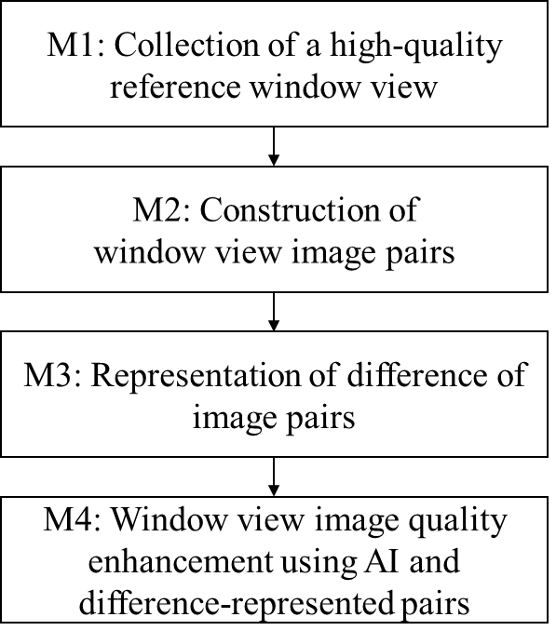
Figure 1. Workflow of the proposed method.
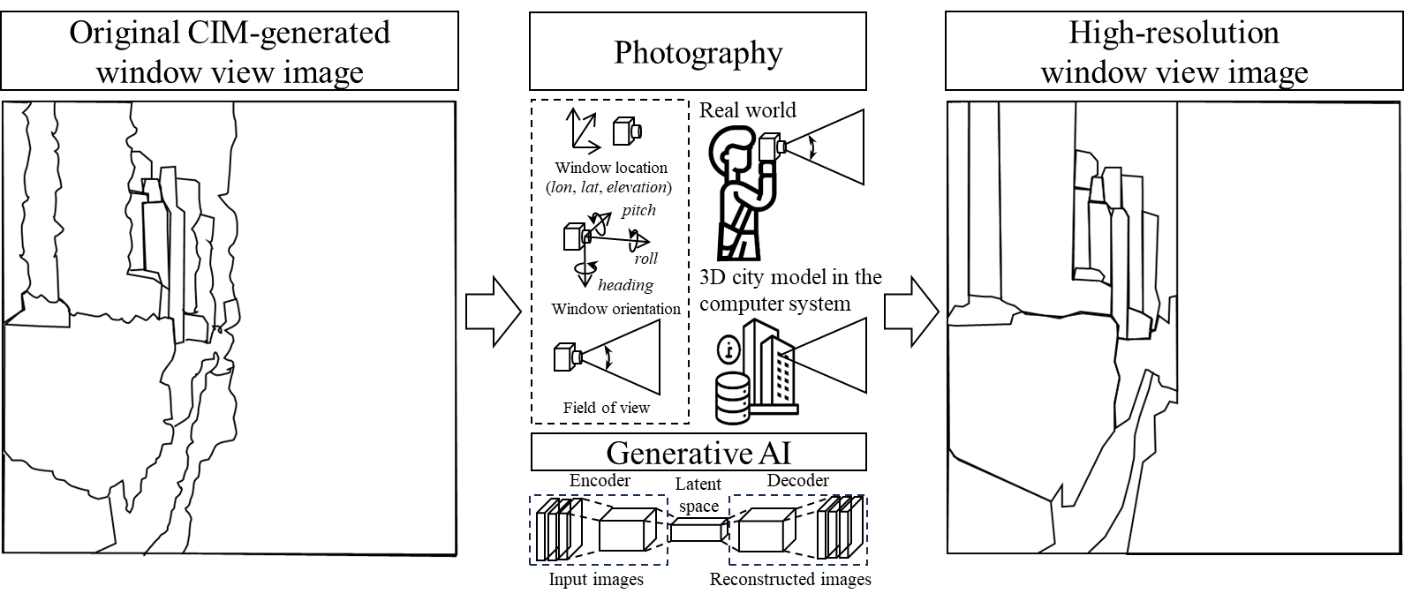
Figure 2. Collection of a high-resolution window view as a reference.
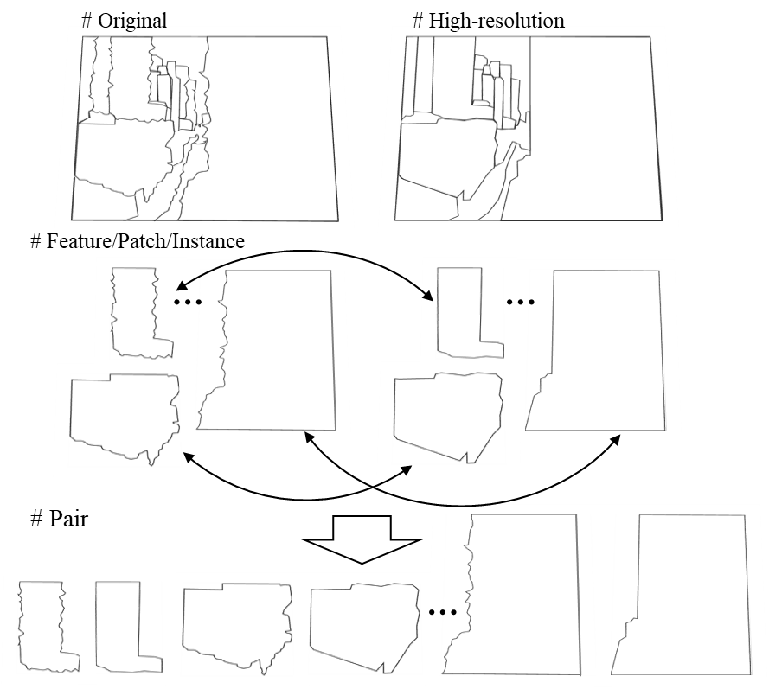
Figure 3. Construction of window view image pairs.
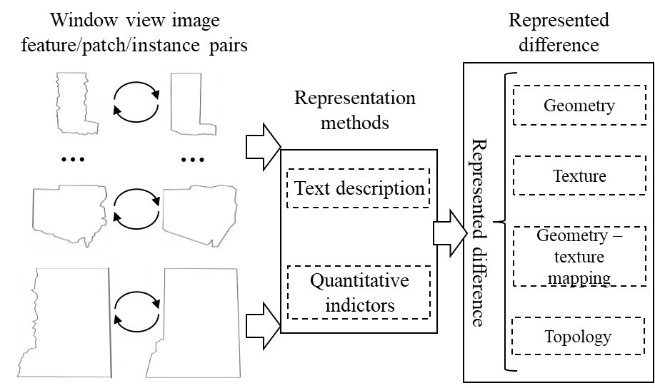
Figure 4. Representation of difference of image pairs.
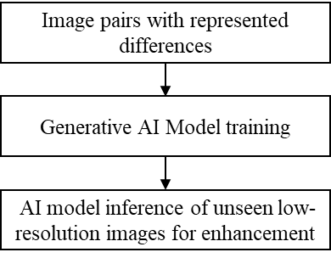
Figure 5. Window view image quality enhancement using AI and difference represented pairs.

Technical Description through an Example Case
The key techniques are illustrated with an example case. It should be noted that the case only illustrates the general idea of this invention and are therefore not to be considered limiting this scope. Similar data and methods can also be used to improve the 3D model-generated window view images following the general workflow as shown in Figure 1.

M1: Collection of a high-quality reference window view image. In M1, the Generative AI models are used to generate high-quality window view images, with prompts directing quality enhancement while maintaining the view composition and spatial layout (see Figure 6a). Specifically, the high-quality 3D model-generated window view images are first generated based on the original images through a text-to-image Generative AI model, Flux.1-dev. The prompts for the image enhancement include “remove the distortion of the building facades, enhance the resolution; avoid the blurs; do not change the building texture and structure;” Multiple generations based on original images and improved prompts are conducted to achieve a most similar and high-quality window view image.

M2: Construction of window view image pairs. Since parts of the high-quality images generated by Flux.1-dev have randomly generated scene details and window view structures, we first manually annotate matched city objects in the original and high-quality images in a self-designed human-interactive Python program. The matched city objects should have similar extents and landscape types in the image (see Figure 6b). By contrast, the mismatched pairs, e.g., a flat roof in the original image and a wrongly generated road in the high-resolution image, are excluded. Then, we clip the pairs out through an automatic overlaying in Python. Last, the result segment pairs at the instance level are manually examined to exclude the overlooked mismatched pairs.

M3: Representation of difference of the image pair. The instance differences between the original image/patch/instance and the generated high-quality image/patch/instance are defined by three aspects: texture, geometry, and resolution. The improvement types of texture and geometry include: unchanged and improved, while the resolution improvement includes: similar and increased. The difference between image pairs includes four types of resolution and content (texture + geometry) improvement: i) similar and unchanged, ii) increased and unchanged, iii) similar and improved, and iv) increased and improved. Then, prompts based on the improvement types are constructed from the original to the improved to represent the difference (see Figure 6c). For example, for the patch pairs in the category “increased and unchanged”, the prompt is “increased resolution; unchanged texture and geometry; 3D models; urban landscape”, while the prompt for the patch pairs in the category “similar and improved” includes “increased resolution; improved texture and geometry; 3D models; urban landscape.” We also conduct image patch augmentation to expand and diversify the image-text pairing set (see Figure 6c). One example is blurring the patch with the same geometry and texture, together with the changed prompt, e.g., “no change of texture and geometry but worsening resolution.”

M4. Window view image quality enhancement using AI and difference-represented pairs. First, the instruct pix2pix model is trained on the constructed patch pairs and prompts (see Figure 6d). Hyperparameters, e.g., learning rate and batch size, are finetuned to achieve the best performance (minimal loss on the validation set) of the model. Early stop method is applied to avoid overfitting. Then, the trained model is applied to enhance the quality of unseen 3D model-generated window view images with the prompt, “increased resolution; unchanged texture and structure; 3D models; urban landscape.” Figure 6e shows the improved 3D model-generated images.
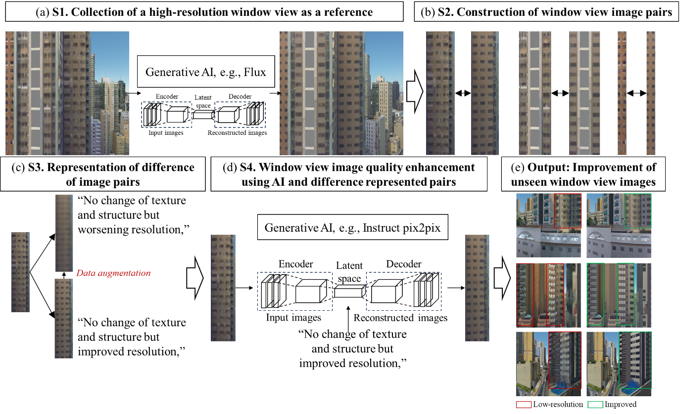
Figure 6. Workflow of the case application.

- GRANTS / FINANCIAL SUPPORT / CONTRACTUAL OBLIGATION
Note: Identify the specific grant or contract number (s) and the external sponsors (governmental agencies, industrial sponsors, private organization, or others) contributing to the research that led to the invention. Click the “+” sign on the bottom right corner to add an extra row.
Name of Sponsor  (e.g. ITF, GRF) | Grant/contract no. | Project Title and Project End Date | Name of  Project-In-Charge | Funding for Patent Costs
- Nil |  |  |  | ☐ No, no funding.  ☐ Yes, percentage or amount covered:

- PUBLIC DISCLOSURE
Has this invention been publicly disclosed (e.g. conference presentation or publication)?
☒ No, it has not been made available to the public.
☐ Yes, when and where was this invention disclosed:
If the invention has not been publicly disclosed, indicate when and where it will be disclosed:

- STAGE OF DEVELOPMENT:
Note: Please check which of the following most closely describes the current stage of your invention
☐ | Concept Only | ☐ | Preliminary Data | ☐ | Intermediate Data | ☒ | Complete Proof of Concept | ☐ | Prototype Available (If applicable)
Are there any limitations in the current invention or challenges that needed to be overcome before a practical product may be developed?

The ground truth scene of the original image may not be recaptured in the real world due to urban redevelopment. The biased number of window view pairs with improvements of blurs, distortion, and limited resolution, may hinder a comprehensive AI model training.
Will you continue your work to overcome these limitations/challenges? What is your future development plan? Please describe.
Work to overcome the limitations
- Design strategies on data augmentation to improve the possible biased number of window view pairs with improvements of blurs, distortion, and limited resolution.

Development plan
- Construct a prototype to test and optimize the feasibility of the system and methods.

- PATENT AND LITERATURE SEARCH
Note: Please undertake a careful patent and literature search in respect of your invention. The recommended websites for patent and literature search are: PCT Full Text Database, Google Patent Search, Google Scholar, USPTO, CNIPA, Espacenet.
  - Keyword(s) used in the patent or literature search
Image Editing; Image Matching; Window View; Landscape View; City Information Model; Generative AI; AI; Artificial Intelligence; Texture repair; Image Beautification; Image Repairing; Image inpainting
  - Please list out at least two “prior arts”, that is, similar patent documents and/or literature found, and point out the major differences between the prior arts and your present invention. Click the “+” sign on the bottom right corner to add an extra row.
- System and method for synthetic image generation with localized editing
Type of Reference: ☒ Patent Document ☐ Literature ☐ Market available product or technology
Patent Document no., Title of Literature, or Webpage: US 11,508,169 B2, System and Method for Synthetic Image Generation with Localized Editing

Difference(s):
This patent provides a system and method for generating synthetic images with localized customization using an enhanced generative adversarial network (GAN). Compared to our invention,
- first, the objectives of the patent differ. The patent emphasizes style transfer of semantically meaningful local regions of the source image to the target image. By contrast, our invention does not aim for style transfer; instead, it is designed to enhance low-quality images or patches with blurs, distortions, and missing details.
- Second, the workflow disclosed in the patent differs. The patent relies on GAN algorithms to perform style transfer, whereas our invention employs multiple optional types of AI image generation algorithms, e.g., GAN, and diffusion models.
- Last, the patent includes neither the steps of constructing window view pairs nor representing the differences of the pairs for low-resolution window view image improvement. Our invention presents how to construct a window view pair, considering the high cost to collect a relatively high-resolution and matched window view. Additionally, our invention includes a step to represent the differences of the image pairs. The represented difference supports AI models to learn improvement of texture, geometry, and resolutions between low-quality and high-quality patches. Conversely, the inevitable content variations between window view pairs caused by the reasons discussed in Section 3a are excluded from the learning process.

Is the difference a result of a routine modification/optimization?
☐ Yes ☒ No
Does the difference contribute to the advantageous effect achieved by your invention?
☒ Yes ☐ No, how: The construction of window view pairs collects matched scene elements in both low-quality and high-quality. By distinguishing quality differences, e.g., texture, geometry, and resolution, from content difference, our method based on AI image generation algorithms specifically supports the enhancement of the original images’/patches’ quality of rather than styles or content.

- Training method of image editing model, image editing method and device
Type of Reference: ☒ Patent Document ☐ Literature ☐ Market available product or technology
Patent Document no., Title of Literature, or Webpage: CN 116,363,261 B, Training Method of Image Editing Model, Image Editing Method and Device

Difference(s):
This patent provides training method of diffusion-based image inpainting models using texts as prompts. Compared to our invention,
- first, the objectives of the two are different. This patent emphasizes editing local areas of images by first adding masks and then performing inpainting guided by text prompts, whereas our invention focuses on enhancing low-quality view images or patches without masking and inpainting.
- Second, the disclosed workflow of the patent differs. The implementation of the patent is based on diffusion algorithms for image inpainting, whereas our invention is applicable with multiple types of AI image generation algorithms, e.g., GAN, and diffusion models.
- Last, the patent does not confine the randomness of inpainting content generated by prompts, whereas our invention controls the randomness by constructing highly matched window view pairs, representing the content difference, and guiding the learning process to improve texture, geometry, and resolution between low-quality and high-quality images/patches.

Is the difference a result of a routine modification/optimization?
☐ Yes ☒ No
Does the difference contribute to the advantageous effect achieved by your invention?
☒ Yes ☐ No, how: Our invention is designed to enhance low-quality window view images and patches generated from 3D models. The four proposed steps are tailored to restrict the AI’s learning process to the differences between low-quality and high-quality images or patches, regardless of content variations resulting from possible mismatching.

- System and Methods for Quantifying and Calculating Window View Openness Indexes
Type of Reference: ☒ Patent Document ☐ Literature ☐ Market available product or technology
Patent Document no., Title of Literature, or Webpage: WO 2023/179296 A1, System and Methods for Quantifying and Calculating Window View Openness Indexes
Difference(s):
This patent provides a system and methods for quantifying window view openness indexes based on window view photos and view distance. Compared to our invention,
- first, the objective of the patent is different. The patent focuses on quantifying openness of a window view by integrating proportions of visible elements, e.g., sky, and the distance, whereas our invention emphasizes improving the low-resolution window view images or patches without any openness quantification.
- Second, the disclosed window view generation of the patent differs. The patent includes collection of window view images through real-world photography or virtual photography from a computer system for subsequent openness quantification. In contrast, our invention is compatible with multiple methods, e.g., photography and Generative AI, to generate relatively high-resolution window views or patches.
- Last, our invention includes another three steps, i.e., constructs window view pairs using methods, e.g., image matching, representation difference of window view pairs, and 3D model-generated window view quality enhancement via Generative AI, whereas the mentioned patent does not include.

Is the difference a result of a routine modification/optimization?
☐ Yes ☒ No
Does the difference contribute to the advantageous effect achieved by your invention?
☒ Yes ☐ No, how: Our invention is different from the mentioned patent. The particularly designed four-step workflow effectively collects high-quality window view images as reference, constructs window view pairs through segmentation, and identifies and learns the difference between low-quality and high-quality images/patches for 3D model-generated window view quality enhancement, whereas the mentioned patent does not focus on the quality of window view images.
- Semantic image translation for repairing the texture defects of building models
Type of Reference: ☐ Patent Document ☒ Literature ☐ Market available product or technology
Patent Document no., Title of Literature, or Webpage: Semantic image translation for repairing the texture defects of building models
Difference(s):
This paper provides a method to improve the texture defects of building models through restoring and translation of the structure mask of the building facades. Compared to our invention,
- first, the objective of the paper is different. The paper focuses on repairing defects of building models from the texture aspect, whereas our invention emphasizes improving 3D model-generated 2D window view images from multiple aspects, e.g., texture, geometry, and resolution.
- Second, the disclosed workflow of the paper differs. The paper includes collection of building models’ façade structure masks, repairs them, and then translate them into improved building façade textures. In contrast, the four-step workflow in our invention collects high-quality window view images as reference, constructs window view pairs through segmentation, and identifies and learns the difference between low-quality and high-quality images/patches for 3D model-generated window view quality enhancement.

Is the difference a result of a routine modification/optimization?
☐ Yes ☒ No
Does the difference contribute to the advantageous effect achieved by your invention?
☒ Yes ☐ No, how: Our invention differs from the mentioned patent. The four-step workflow in our invention collects high-quality window view images as reference, constructs window view pairs through segmentation, identifies the difference between low-resolution to high-resolution images/patches, and learns the difference through Generative AI for 3D model-generated window view quality enhancement. In contrast, the referenced paper does not focus on 2D window view images; instead, it primarily addresses texture defects in 3D building models.
- Semantic image translation for repairing the texture defects of building models
Type of Reference: ☐ Patent Document ☐ Literature ☐ Market available product or technology
Patent Document no., Title of Literature, or Webpage: HQ-Edit: A High-Quality Dataset for Instruction-based Image Editing
Difference(s):
This paper provides a method to generate image pairs with instructions to enhance performances of existing instruction-based image editing AI models. Compared to our invention,
- first, the objective of the paper is different. The paper focuses on generating both high-quality original and edited images based on instructions, utilizing up-to-date AI models, e.g., DALL-E 3 and GPT-4, to enhance the performance of existing instruction-based image editing AI systems. In contrast, our invention aims to improve the low-quality 3D model-generated window view images.
- The inputs and outputs of the two are different. The high-quality image pairs in the paper are randomly generated based on prompts and instructions. In contrast, the low-quality window view images in our invention are generated from 3D models while reference high-quality window view images are generated from multiple optional sources, e.g., real-world photography, virtual photography from a computer system, and Generative AI. Note that low-quality 3D model-generated window view images and high-quality reference without changing content (texture + geometry) are impractically generated using the method of the mentioned paper.
- Specific strategies in our invention are designed to enhance low-quality 3D model-generated window view images. Unlike general image editing in the mentioned paper, 3D model-generated window view image improvement through Generative AI is challenging due to difficulty in collecting corresponding high-quality window view images for constructing annotation datasets. Our invention presents methods to generate high-quality window view images as reference, construct the window view image pairs through segmentation, and represent difference across three aspects, e.g., texture, geometry, and resolution.

Is the difference a result of a routine modification/optimization?
☒ Yes ☒ No
Does the difference contribute to the advantageous effect achieved by your invention?
☒ Yes ☐ No, how: Our invention differs from the mentioned paper that focuses on general image editing. The primary challenge in enhancing 3D model-generated window view images through Generative AI is the construction of paired low-quality and high-quality window view images. Our invention presents methods to collect high-quality window view images as reference, constructs the window view image pairs through segmentation, identifies the difference between low-resolution to high-resolution images/patches, and learns the difference through Generative AI for 3D model-generated window view quality enhancement. In contrast, the referenced paper does not focus on 2D window view images. The method is not applicable for improving low-quality 3D model-generated window view images.

- POTENTIAL COMMERCIAL APPLICATIONS OF THE INVENTION:
a. Is there any product in the market that may compete with this invention? List some of the key brands/manufacturers.
To the best knowledge of the applicants, there is no product in the market that may compete with the proposed invention.
b. Please list the companies and specific contacts of parties that have expressed interest or may be interested in the invention.
Geo-science related educational and technical institutions:
- The University of Hong Kong (HKU)
- Dongguan Guangliang Holding Group Co., Ltd
- GLHK Solution Limited
- Geosys Hong Kong Ltd.
- Esri China (Hong Kong) Ltd.

Users in surveying, urban planning, and housing fields:
- Lands department of Hong Kong SAR
- Planning department of Hong Kong SAR
- Urban Renewal Authority (URA)
- Housing Authority
- Housing Society
- Sun Hung Kai Properties
- Centaline Property Agency Limited

Note: Potential companies and parties are not only limited to Hong Kong and mainland China. Generally, it can attract interest from the fields of urban planning and real estate around the world.
c. Estimated cost of manufacturing/implementing this invention.
The invention needs a high-performance camera and GPU workstation to realize the computation. For instance, initially, the high-quality reference window view images are captured using either a real camera or virtual camera in a computer system. The high-quality window view images through Generative AI need to be generated in a computer system with GPUs. Then, representation of difference of window view pairs and Generative AI model training also rely on a workstation with enough memory, CPU, and GPU. Last, for a computer system, the memory and CPU directly determine the efficiency for improvement of other unseen low-quality window view images.
The cost of the workstation and building the prototype system is HK$ 60,000.
d. List up to three jurisdictions, if any, that you consider to be the most important markets for this invention and most prefer to have a patent registered in the said jurisdictions. For example, HK, China, US, Europe, etc.
1. HK 2. China 3. US

- THIRD PARTY MATERIALS
Note: Please describe any materials obtained from third parties (such as research collaborators or companies, with or without a Material Transfer Agreement) that were used in the development of the invention or incorporated in the invention.
☒ No third-party material or data was used.
☐ Identify the materials used and provide relevant material transfer or data sharing agreement, if available:

- Signature by HKU Inventor(s):

I/We, the inventor(s), assign all of our interest in and to the invention herein described, together with any further improvements, to the University of Hong Kong (HKU). I/We, the inventor(s) represent and warrant that:-
- Each of us has read the completed invention disclosure,
- I/We agree on our relative percent contribution to the technology disclosed and our percent contribution will be used to determine each inventor’s revenue share, regardless of inventorship status. If the percent contribution of each inventor is not indicated, it will be assumed that each contributed equally.
- I/We agree that revenue derived from the invention, if any, will be distributed per HKU’s current policy. I/We will make a reasonable commitment of my/our time towards the assessment, patenting and commercialization of the technology.
- I/We agree that the IDF may be electronically signed and the electronic signatures appearing on the IDF are the same as handwritten signatures for the purposes of validity, enforceability and admissibility.

First HKU Inventor
 |  |  | Type or Click to select a date
 | Inventor’s Signature |  | Date |  | Name (in BLOCK letters)
Second HKU Inventor
 |  |  | Type or Click to select a date
 | Inventor’s Signature |  | Date |  | Name (in BLOCK letters)
Third HKU Inventor
 |  |  | Type or Click to select a date
 | Inventor’s Signature |  | Date |  | Name (in BLOCK letters)
Fourth HKU Inventor
 |  |  | Type or Click to select a date
 | Inventor’s Signature |  | Date |  | Name (in BLOCK letters)
Fifth HKU Inventor
 |  |  | Type or Click to select a date
 | Inventor’s Signature |  | Date |  | Name (in BLOCK letters)

- Signature by Non-HKU Inventor(s):
* Not applicable to inventor(s) whose IPR is owned by another organization and will not be assigned to HKU. See s.12(b), Appendix A for detail

I/We, the inventor(s), assign all of our interest in and to the invention herein described, together with any further improvements, to The University of Hong Kong (HKU). I/We, the inventor(s) represent and warrant that:-
- Each of us has read the completed invention disclosure,
- I/We agree on their relative percent contribution to the technology disclosed and my/our percent contribution will be used to determine each inventor’s revenue share, regardless of inventorship status. If the percent contribution of each inventor is not indicated, it will be assumed that each contributed equally.
- I/We agree that revenue derived from the invention, if any, will be distributed per HKU’s current policy or subsequent joint ownership agreement to be made between HKU and I/us, whichever is applicable. I/We will make a reasonable commitment of my/our time towards the assessment, patenting and commercialization of the technology.
- I/We agree that the IDF may be electronically signed and the electronic signatures appearing on the IDF are the same as handwritten signatures for the purposes of validity, enforceability and admissibility.

First Non-HKU Inventor
 |  |  | Type or Click to select a date
 | Inventor’s Signature |  | Date |  | Name (in BLOCK letters)
Second Non-HKU Inventor
 |  |  | Type or Click to select a date
 | Inventor’s Signature |  | Date |  | Name (in BLOCK letters)
Third Non-HKU Inventor
 |  |  | Type or Click to select a date
 | Inventor’s Signature |  | Date |  | Name (in BLOCK letters)
Fourth Non-HKU Inventor
 |  |  | Type or Click to select a date
 | Inventor’s Signature |  | Date |  | Name (in BLOCK letters)
Fifth Non-HKU Inventor
 |  |  | Type or Click to select a date
 | Inventor’s Signature |  | Date |  | Name (in BLOCK letters)

Encl/ Appendix A: Guidelines for Completing the IDF

See section 6, HKU IPR Policy, available at http://www.rss.hku.hk/contracts/ipr for more detail.
Check out HKU TTO website https://www.tto.hku.hk/for-researchers/forms-agreements-and-other-templates/invention-disclosure-form or email us for a copy.
See section 6.6.3, HKU IPR Policy, available at http://www.rss.hku.hk/contracts/ipr for more detail.

